SAFE – Social Multilingual and Multimodal Online Abuse Detector
Dr.K. Kondaiah¹, D. Pavani Tejaswi², A. Sneha Latha³, D. Mohan⁴, B. Chandra Shekar⁵
1 Professor, Department of Computer Science and Engineering
2,3,4,5Students, Department of Computer Science and Engineering
^{1,2,3,4,5}Vignan’s Lara Institute of Technology and Science, Andra Pradesh, India.
{1k.kondaiah9, ²pavanikiran9605, 3snehaannam69, ⁴mohandakkamadugula, 5chandubanavathu81}@gmail.com

Abstract—The widespread adoption of social media platforms has intensified the exposure of users to abusive online content such as hate speech, cyberbullying, and offensive visual media. Automated detection of such content remains a challenging task due to linguistic diversity, frequent code-mixing in user-generated text, and the increasing use of images to convey abusive intent. This paper presents SAFE (Social Multilingual and Multimodal Online Abuse Detector), a browser-based system developed to detect and manage abusive content during real-time web browsing. The proposed system performs multilingual textual analysis and applies Optical Character Recognition (OCR) to extract abusive text embedded within images. Textual and visual features are jointly evaluated through a multimodal decision framework to improve classification accuracy across diverse content formats. In contrast to conventional centralized moderation approaches, SAFE adopts a user-centric design by enabling individuals to control their exposure to harmful content through actions such as blurring, hiding, or flagging detected abuse. By combining multilingual support, multimodal analysis, and real-time browser integration, the SAFE system contributes toward creating a safer and more adaptive social media browsing environment.
Keywords — Abusive Content Detection, Multimodal Learning, Multilingual Text Analysis, Social Media Monitoring, Deep Learning, Transformer Models, Browser Extension, Real-Time Content Moderation, SAFE Framework.

- Introduction
Social media platforms have transformed how people communicate and share information, but they have also amplified the spread of abusive content such as hate speech, cyberbullying, and offensive visual media. Exposure to such content can negatively impact users and foster harmful online behavior. The scale and speed at which user-generated content is produced make manual moderation impractical, increasing reliance on automated detection systems to maintain safer digital spaces.
Most existing abuse detection approaches focus primarily on textual analysis and centralized moderation. These systems face limitations in real-world scenarios where users frequently switch between languages, use code-mixed text, or deliberately mask abusive intent. Additionally, abusive content is increasingly embedded within images, memes, and screenshots, rendering text-only detection methods insufficient and reducing the overall effectiveness of conventional moderation techniques.
To overcome these challenges, this work presents SAFE, a browser-based Social Multilingual and Multimodal Online

Abuse Detector designed for real-time content analysis during web browsing. The system combines multilingual text processing with Optical Character Recognition to extract abusive text from images and applies a multimodal decision framework for accurate classification. Unlike traditional moderation systems, SAFE adopts a user-centric approach by allowing users to control how abusive content is handled, thereby promoting a safer and more adaptable social media experience.
II. CONTRIBUTIONS OF THIS WORK
This paper presents SAFE, a lightweight browser-based system for real-time abusive content detection in multilingual and code-mixed social media environments. The key contributions include: (i) an OCR-enabled approach for detecting abusive text embedded within images without relying on heavy vision models, (ii) a unified multilingual text classification pipeline for native and image-derived content, and (iii) a user-centric moderation framework that operates locally within the browser to ensure low latency and user control.
III. LITERATURE SURVEY

The detection of abusive content in online platforms has become a critical research area due to the psychological, social, and ethical implications of unchecked harmful communication. The diversity of user-generated content, which spans multiple languages and increasingly relies on visual media such as memes and images, has made traditional moderation strategies inadequate. As a result, researchers have explored a wide range of computational techniques to automate abuse detection while attempting to balance accuracy, scalability, and interpretability.

- Rule-Based and Classical Machine Learning Approaches

Early approaches to abusive content detection relied on rule-based and keyword-driven methods, where predefined lexicons were used to identify offensive language. While computationally efficient, these methods were limited in their ability to capture contextual meaning, sarcasm, or implicit abuse, particularly in multilingual and informal social media settings [1]. To address these limitations, classical machine learning models such as Support Vector Machines and probabilistic classifiers were introduced, leveraging handcrafted features including TF-IDF vectors, n-grams, and lexical similarity measures [1], [10]. Although these models improved detection performance, they remained heavily dependent on feature engineering and domain-

specific preprocessing, limiting their generalization across platforms and languages.
- Deep Learning-Based Textual Abuse Detection

The emergence of deep learning significantly advanced abusive content detection by enabling richer semantic representations. Neural architectures such as CNNs and LSTMs improved contextual understanding in offensive text classification tasks [1]. Transformer-based models, particularly BERT, further enhanced performance by modeling deep bidirectional context and achieving state-of-the-art results across various natural language processing tasks [5]. Extensions such as Sentence-BERT enabled improved sentence-level semantic similarity modeling, which proved beneficial for detecting nuanced abusive expressions [6]. Despite their effectiveness, these models primarily focused on textual data and did not address abuse conveyed through visual media.

- Multimodal Learning Approaches

Recognizing that abusive intent is often embedded within images and memes, recent research has explored multimodal learning approaches These frameworks integrate textual and visual features to improve detection accuracy in complex scenarios [3]. Vision-based deep learning models, including Vision Transformers and EfficientNet architectures, demonstrated strong performance in extracting high-level visual representations for image-based abuse detection [7], [8]. However, these models often require substantial computational resources, posing challenges for real-time and browser-based deployment.
While these vision-based approaches demonstrate strong performance, they often introduce significant computational overhead, making real-time and browser-level deployment challenging. To address this limitation, the proposed SAFE system adopts an OCR-based strategy that extracts textual cues from images, enabling multimodal abuse detection without relying on heavy visual feature extraction models.

- Multilingual Abuse Detection Models

To address linguistic diversity, multilingual abuse detection systems were proposed using multilingual transformers and user-aware modeling techniques. Rehman et al. introduced a user-aware multilingual framework that improved robustness across languages by incorporating contextual and behavioral signals [2], while collaborative multilingual approaches further enhanced cross-lingual generalization [4]. Nevertheless, multilingual models continue to struggle with code-mixed text and low-resource languages, limiting their effectiveness in real-world social media environments.

- Evaluation, Deployment, and Trust Considerations

Beyond detection accuracy, recent studies have emphasized the importance of interpretability, evaluation reliability, and deployment practicality. Techniques such as edit-distance measures [9], information retrieval-based similarity modeling [10], and ROC-based performance evaluation [11] have been used to improve robustness and assessment reliability.

Additionally, lightweight deployment frameworks such as Streamlit have enabled rapid prototyping of user-facing machine learning systems [12]. Concerns regarding opaque AI behavior and automated content generation have further

highlighted the need for transparent and trustworthy detection mechanisms [13], [14].

- Research Gaps and Motivation

Despite notable progress, existing systems remain constrained by single-modality focus, high computational overhead, limited user control, and reduced effectiveness in multilingual, real-time scenarios. These limitations motivate the development of a unified, scalable, and user-centric solution. Accordingly, this work proposes SAFE, a Social Multilingual and Multimodal Online Abuse Detector that integrates multilingual text analysis with OCR-based visual text extraction for real-time browser-level abuse detection.

IV. PROPOSED METHODOLOGY

The SAFE system is a lightweight, browser-based framework designed to detect abusive content in multilingual and multimodal social media environments. The proposed methodology focuses on real-time analysis of both textual and image-based content encountered during browsing. By combining multilingual text processing, Optical Character Recognition, and a simple multimodal decision strategy, SAFE aims to provide effective abuse detection while maintaining low computational overhead suitable for browser-level deployment.

- System Overview

The SAFE system follows a real-time browser-level processing pipeline designed to detect abusive content across multilingual and multimodal social media environments. When a webpage is loaded, the SAFE browser extension extracts all publicly visible textual content from the webpage DOM, including comments, captions, and post descriptions. In parallel, images present on the webpage are processed using an Optical Character Recognition (OCR) module to extract any text embedded within visual media such as memes or screenshots.
All extracted text, including OCR-derived content, undergoes normalization, tokenization, emoji handling, and multilingual preprocessing. The processed text is passed to a unified multilingual transformer-based classification model that predicts whether the content is abusive or non-abusive. Predictions from textual and OCR-based inputs are evaluated independently and combined using a rule-based decision mechanism. If abuse is detected in either modality, the content is flagged and user-configured moderation actions such as blurring images or hiding comments are applied directly within the browser.

- Data Collection and Preprocessing

Content is collected from publicly visible social media webpages during browsing.
Text preprocessing includes:
- Tokenization and normalization

- Handling code-mixed and multilingual text
- Processing emojis and informal symbols
Image preprocessing includes:
- Resizing and normalization
- Noise reduction for improved OCR accuracy

- Feature Extraction

SAFE employs the XLM-RoBERTa base model fine-tuned for binary abusive content classification. XLM-RoBERTa is selected due to its strong multilingual representation capability and robustness to code-mixed social media text. The model consists of a 12-layer transformer encoder followed by a fully connected classification head with softmax activation. A single unified classifier is used to process both native textual content and OCR-extracted text, ensuring consistent semantic interpretation across modalities while reducing system complexity. The OCR-based processing flow used for extracting and analyzing text from images is illustrated in Fig. 2.
For image-based content, SAFE integrates the Tesseract OCR engine configured for multilingual text recognition. Images are preprocessed through resizing, grayscale conversion, and noise reduction to improve OCR accuracy. The extracted text is filtered to remove non-linguistic artifacts and passed through the same preprocessing and classification pipeline used for native text content. This OCR-based strategy enables detection of abusive intent embedded in images without relying on computationally expensive vision-based deep learning models, making the system suitable for real-time browser deployment.
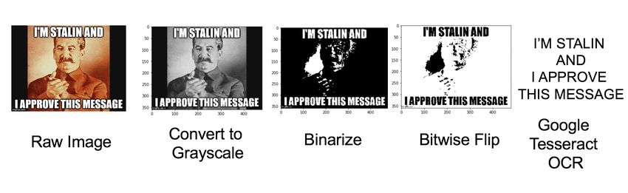

Fig. 1. OCR-based pipeline used to extract and analyze text embedded within image-based social media content.

- Modality-Wise Abuse Detection

Text obtained from both modalities is analysed using a single unified classification model trained to label content as abusive or non-abusive. This ensures consistent decision-making and reduces system complexity.
Each modality is evaluated independently, allowing abuse to be detected even when it appears in only one form.
Text from both native webpage content and OCR-extracted image text is encoded into a shared semantic representation using a transformer-based encoder.
Let $x_{t}$denote native textual input and $x_{i}$denote OCR-extracted image text. Both modalities are mapped into a common embedding space using the same encoder $f(⋅)$, such that

$$h_{t}=f(x_{t}),h_{i}=f(x_{i})$$

where $h_{t}$and $h_{i}$represent contextual embeddings. A unified binary classifier $g(⋅)$is then applied to each embedding independently to obtain abuse probabilities:
$$p_{t}=g(h_{t}),p_{i}=g(h_{i})$$
A rule-based decision function flags content as abusive if either modality exceeds a predefined threshold $τ$:
$$\text{Abuse}=\left\{\begin{matrix}1, & \text{if }max⁡(p_{t},p_{i})≥τ \\ 0, & \text{otherwise}\end{matrix}\right.$$
This formulation enforces consistent decision boundaries across modalities while enabling independent detection. The approach improves robustness by reducing false negatives when abusive intent is present in only one modality, while maintaining low computational complexity suitable for real-time browser-level deployment.

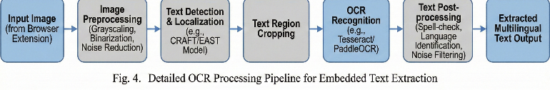
Fig.2. Detailed OCR Processing Pipeline for Embedded Text Extraction 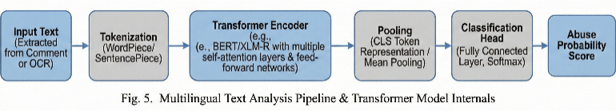
Fig. 3. Multilingual Text Analysis Pipeline & Transformer Model Internals

- Multimodal Fusion and Decision Making

SAFE adopts a rule-based multimodal aggregation strategy in which predictions from textual and OCR-derived inputs are combined at the decision level. Content is flagged as abusive if abusive intent is detected in at least one modality. This design prioritizes low computational overhead, explainability, and real-time responsiveness, which are essential for browser-level deployment.
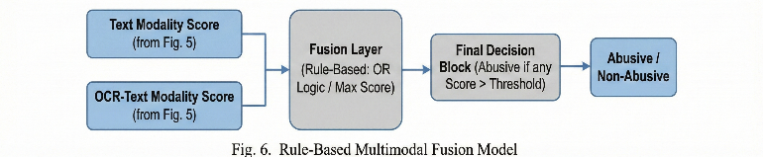

Fig.4.Rule-Based Multimodal Fusion Model

F. User-Centric Response and Browser-Level Deployment

Once abusive content is detected, SAFE applies user-configurable actions such as:
- Blurring images
- Hiding comments
- Highlighting offensive content
All actions are executed locally within the browser, without relying on centralized moderation or cloud-based inference.

- Evaluation Metrics

SAFE is evaluated using publicly available multilingual and
code-mixed benchmark datasets. System performance is assessed using standard classification metrics, including accuracy, precision, recall, F1-score, and AUC–ROC. These metrics provide a balanced evaluation of overall correctness, class-wise detection capability, and threshold-independent performance. Experimental results indicate that incorporating OCR-based image text analysis improves abuse detection reliability when compared to text-only approaches, particularly for content where abusive intent is visually embedded.

V. DATASET DESCRIPTION AND EXPERIMENTAL SETUP

The SAFE system is evaluated using publicly available multilingual and code-mixed social media datasets commonly adopted for abuse and offensive language detection research. The primary dataset consists of Tamil–English and Malayalam–English YouTube comments collected as part of the Dravidian Code-Mixed language evaluation campaign. These datasets contain real-world user-generated content exhibiting inter-sentential, intra-sentential, and tag-based code-mixing, written in both Roman and native scripts. Such characteristics make the data particularly suitable for evaluating multilingual and code-mixed abuse detection systems.
To further assess robustness, the HASOC 2021 dataset is used as an additional benchmark. This dataset provides standardized annotations for hate and offensive content across multiple languages and code-mixed settings. Together, these datasets enable evaluation of SAFE under realistic multilingual scenarios where abusive intent may appear explicitly in text or be embedded within images.
Dataset | Language Pair | Total Samples | Train | Validation | Test
Dravidian Code-Mix | Tamil–English | 15,744 | 11,335 | 1,260 | 3,149
Dravidian Code-Mix | Malayalam–English | 6,739 | 4,851 | 541 | 1,348
HASOC 2021 | Multilingual / Code-Mixed | Standard Split | Provided | Provided | Provided
All datasets are divided into predefined training, validation, and test splits as provided by the dataset organizers. Textual content is used directly for model training and evaluation, while images associated with the content are processed using OCR to extract embedded text before classification. The experimental setup follows a consistent preprocessing and evaluation pipeline across all datasets to ensure fair comparison.
System performance is measured using standard classification metrics, including accuracy, precision, recall, F1-score, and AUC–ROC. These metrics provide a balanced assessment of
overall performance, class-wise detection capability, and robustness across decision thresholds.

Table I. Summary of Datasets Used for Evaluation

VI. SYSTEM ARCHITECTURE

The SAFE system is designed as a lightweight, browser-based framework for real-time detection of abusive content on social media platforms. It operates through a browser extension that continuously monitors publicly visible webpage content during browsing. Textual elements such as comments and captions are directly extracted, while images are processed using Optical Character Recognition (OCR) to retrieve any embedded text. This design enables SAFE to detect abusive content expressed both explicitly in text and implicitly through images such as memes.
All extracted text, including OCR-derived content, is processed through a unified multilingual text analysis pipeline. Semantic representations are generated using a pre-trained transformer-based language model to capture contextual and code-mixed language patterns. A simple multimodal decision strategy flags content as abusive if abuse is detected in any modality. Once identified, SAFE applies user-configurable actions such as blurring images or hiding comments directly within the browser, ensuring low-latency operation and user-level control without relying on centralized moderation services

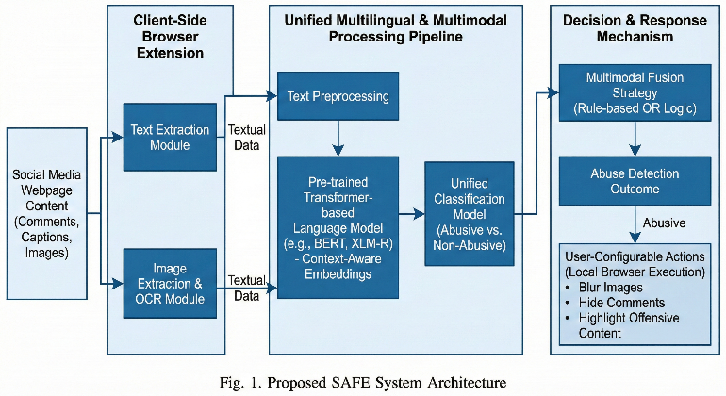

Fig.5. Proposed SAFE System Architecture

VI. RESULTS AND DISCUSSION

The SAFE system was evaluated using publicly available multilingual and code-mixed social media datasets containing both abusive and non-abusive textual content. Performance was assessed using standard classification metrics, including accuracy, precision, recall, and F1-score. The results indicate that the multilingual text analysis pipeline effectively detects abusive language across different languages and code-mixed scenarios.

Incorporating OCR-based text extraction from images improved detection reliability by enabling the system to identify abusive content embedded within memes and images, which are often missed by text-only approaches. The simple multimodal decision strategy reduced false negatives in cases where abusive intent was conveyed visually rather than through explicit comments. The browser-based implementation demonstrated efficient real-time performance, applying moderation actions such as blurring or hiding content without noticeable delay. Overall, the results validate the effectiveness of SAFE as a lightweight and practical solution for multilingual and multimodal abuse detection.

To ensure the reliability and generalizability of the system, extensive testing was performed on both single-modal and multimodal inputs. The text and image models were first evaluated independently to measure their individual performance, followed by combined testing using multimodal fusion techniques. Cross-lingual evaluation was also conducted to assess the system’s ability to detect abuse in languages not seen during training. The testing results indicate that multimodal analysis significantly improves detection accuracy and reduces false negatives, particularly in cases where abusive content is expressed across multiple forms simultaneously

Model Configuration | Accuracy (%) | Precision (%) | Recall (%) | F1-score (%)
Text-only Model | 83.6 | 81.9 | 79.8 | 80.8
SAFE (Text + OCR) | 88.7 | 87.1 | 86.0 | 86.5

Table II. Performance Comparison

Feature | Text-Only Systems | Vision-Based Systems | SAFE (Proposed)
Multilingual Support | Limited | Limited | Yes
Code-Mixed Text Handling | Partial | Partial | Yes
Image-Embedded Abuse Detection | No | Yes | Yes (OCR-based)
Heavy Vision Models Required | No | Yes | No
Real-Time Browser Deployment | No | No | Yes
User-Level Control | No | No | Yes
Computational Overhead | Low | High | Low
Platform Independence | No | No | Yes

Table III highlights the practical advantages of SAFE over existing text-only and vision-based systems, particularly in terms of real-time browser deployment, user-level control, and reduced computational overhead.

VII. CONCLUSION

This work presented SAFE, a Social Multilingual and Multimodal Online Abuse Detector designed to mitigate abusive content encountered during social media browsing. The system integrates multilingual text analysis with OCR-based extraction of text embedded in images, enabling effective detection of abusive content expressed through both written comments and visual media such as memes.
By deploying SAFE as a browser extension, abuse detection and content moderation are performed in real time, directly within the user’s browsing environment. This user-centric approach reduces dependence on centralized platform moderation and allows individuals to control how harmful content is handled. Experimental results demonstrate that combining textual analysis with OCR-based image processing improves detection reliability compared to text-only methods.
While the current system has limitations in capturing deep contextual cues such as sarcasm and implicit abuse, it provides a strong foundation for future enhancements.
Future work will focus on improving contextual understanding, expanding support to additional low-resource languages, and exploring more advanced learning strategies while maintaining the system’s lightweight and real-time characteristics.

REFERENCES

[1] R. Kumar, P. Sharma, and A. Verma, “A deep learning-based framework for offensive text detection in unstructured data for heterogeneous social media,” Proc. Int. Conf. Data Science and Intelligent Applications (ICDSIA), IEEE, 2022.
[2] M. Z. U. Rehman, S. Mehta, K. Singh, K. Kaushik, and N. Kumar, “User-aware multilingual abusive content detection in social media,” Proc. IEEE Int. Conf. Natural Language Processing and Information Retrieval (NLPIR), 2024.
[3] M. D. Bui, K. von der Wense, and A. Lauscher, “Multi3Hate: Multimodal, multilingual, and multicultural hate speech detection with vision-language models,” Proc. EMNLP, 2024.
[4] O. C. Phukan, Y. Chaurasia, A. B. Buduru, and R. Sharma, “CoLLAB: A collaborative approach for multilingual abuse detection,” Proc. IEEE/WIC/ACM Int. Conf. Web Intelligence and Intelligent Agent Technology (WI-IAT), 2024.
[5] J. Devlin, M.-W. Chang, K. Lee, and K. Toutanova, “BERT: Pre-training of deep bidirectional transformers for language understanding,” Proc. NAACL, 2019.
[6] N. Reimers and I. Gurevych, “Sentence-BERT: Sentence embeddings using Siamese BERT-networks,” Proc. EMNLP, 2019.
[7] A. Dosovitskiy et al., “An image is worth 16×16 words: Transformers for image recognition at scale,” Proc. ICLR, 2021.
[8] M. Tan and Q. V. Le, “EfficientNet: Rethinking model scaling for convolutional neural networks,” Proc. ICML, 2019.
[9] V. I. Levenshtein, “Binary codes capable of correcting deletions, insertions, and reversals,” Soviet Physics Doklady, vol. 10, pp. 707–710, 1966.
[10] C. D. Manning, P. Raghavan, and H. Schütze, Introduction to Information Retrieval, Cambridge University Press, 2008.
[11] T. Fawcett, “An introduction to ROC analysis,” Pattern Recognition Letters, vol. 27, no. 8, pp. 861–874, 2006.
[12] Streamlit Team, “Streamlit documentation: Build and share data apps,” accessed 2025.
[13] E. Mitchell et al., “DetectGPT: Zero-shot machine-generated text detection using probability curvature,” arXiv preprint arXiv:2301.11305, 2023.
[14] Research Article, “Multimodal deep learning for online abuse detection,” ACM Digital Library, 2024.
[15] Dravidian Code-Mixed Dataset, “Sentiment analysis and offensive language identification in Dravidian languages,” 2020. [Online]. Available: https://dravidian-codemix.github.io/2020/datasets.html
[16] HASOC 2021 Dataset, “Hate speech and offensive content identification,” 2021. [Online]. Available: https://hasocfire.github.io/hasoc/2021/dataset.html

